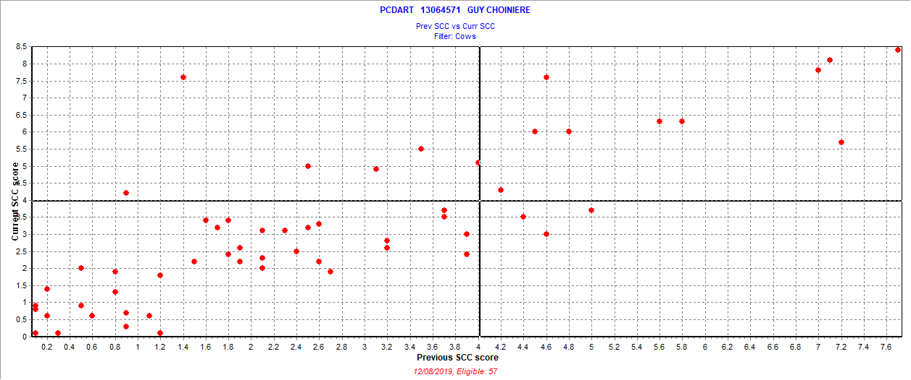

November 11, 2019 test date

New = 6 = 10.5%

Chronic = 10 = 17.5%

Cure = 3 = 5.3%

Uninfected = 38 = 66.7%

Also 3 fresh cows SCC > 3.9